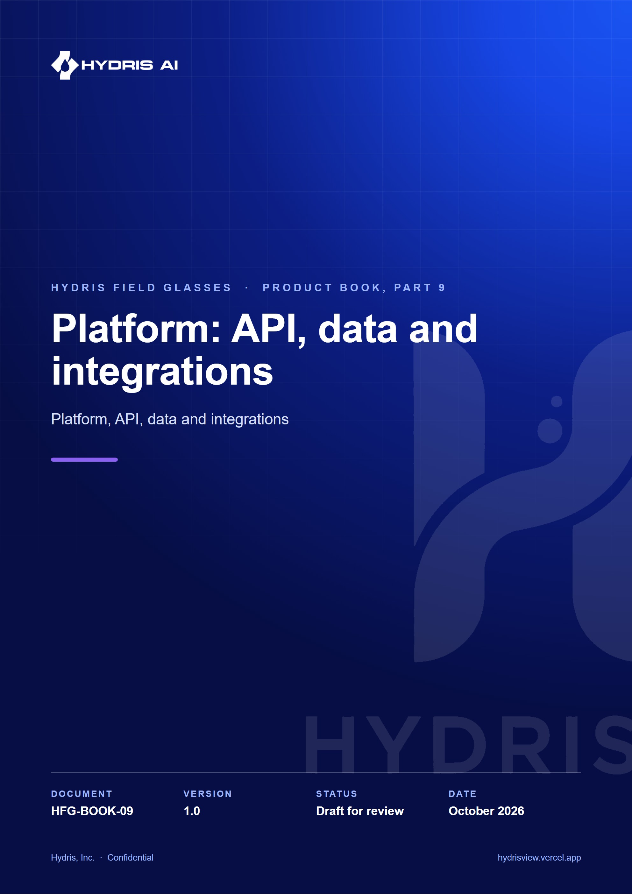
Document control
Document | Platform: API, data and integrations (HFG-BOOK-09)
Version | 1.0
Status | Draft for review
Owner | Product and engineering, Hydris
Audience | Leadership, product, engineering, design, partners and pilot customers
Product | Hydris Field Glasses: website, operator console, glasses app, Android app, API
Source of truth | docs/product/_part09.md in tarun-km/hydrisview (this Word file is generated from it)
Classification | Confidential: Hydris, Inc. and named partners
Revision history
Version | Date | Author | Changes
1.0 | October 2026 | Product and engineering, Hydris | First edition

Contents
1 Platform: API, data and integrations 4
1.1 Architecture in one picture 4
1.2 The modular API 4
1.3 The request lifecycle 6
1.4 Identity, sessions and device tokens 6
1.5 Realtime events 7
1.6 The data model by domain 8
1.7 Tenancy and data isolation 10
1.8 Telemetry ingestion and integrations 11
1.9 AI services and the human in the loop 11
1.10 Background jobs 12
1.11 Key architecture decisions 12
1.12 Platform requirements and NFRs 13
1.13 The technical debt that matters 14

1 Platform: API, data and integrations
Every Hydris surface (website, operator console, glasses HUD, the Hydris Field Android app) talks to one platform: a modular API over one Postgres schema with row-level security. This part explains how that platform is shaped, how a request travels through it, how data is organised and isolated per customer, and how telemetry, AI and background work flow in. It closes with the decisions behind the design, the requirements it meets, and the debt that matters before scale.
15  API route modules  one Fastify instance, `apps/api/src/app.ts` |  | 42  database tables  ten domains, `apps/api/src/db/schema.ts` |  | 3  access control layers  RBAC, site scope, Postgres RLS |  | 0  write paths to plant control  Hydris is read-only to PLC, SCADA and DCS

1.1 Architecture in one picture
Hydris is an npm workspaces monorepo. The API (apps/api, Fastify 5) is a modular monolith. It runs either inside the Next.js web deployment through a catch-all route that calls app.inject (no network hop), or as its own container. A pure TypeScript domain package (packages/domain) holds the state machines, permissions, freshness and voice parsing rules that both server and web use; the Android app mirrors them by hand.
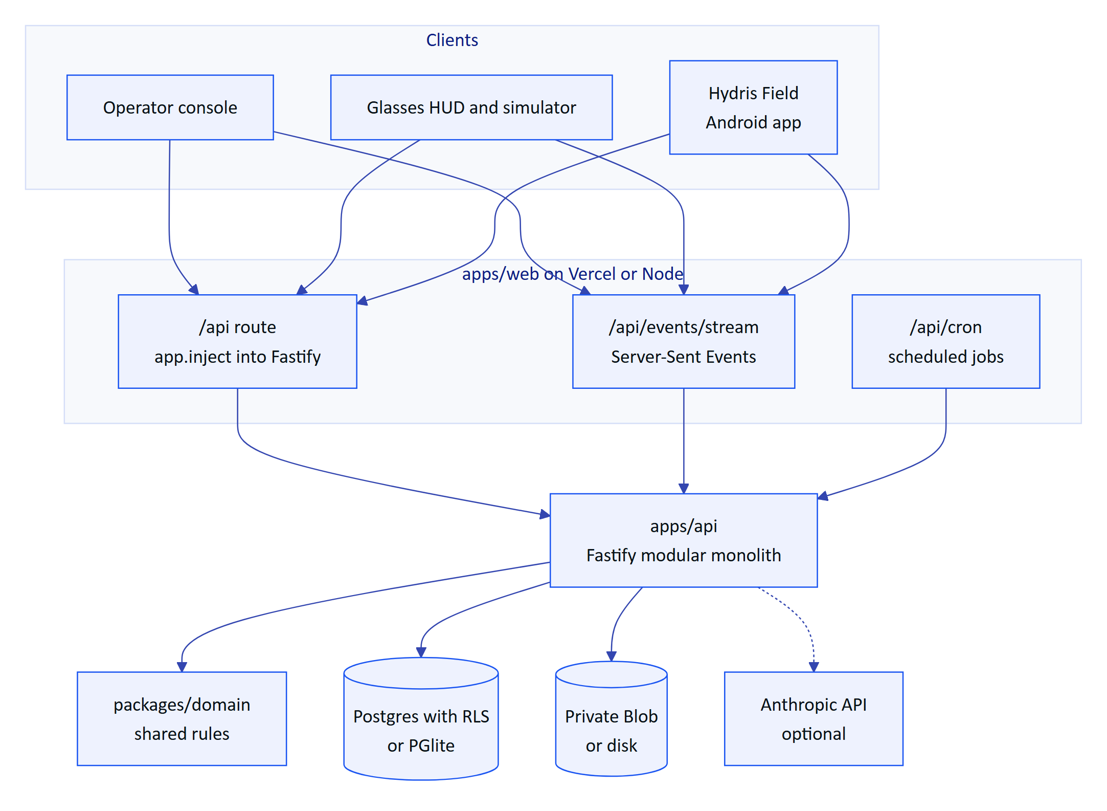
Figure 1. Containers. The API runs inside the web deployment or as its own container; all clients share one API and one event stream.
Configuration is one validated environment (apps/api/src/config.ts): DATABASE_URL selects Postgres or in-process PGlite, REALTIME_MODE selects the event bus, a Blob token selects cloud storage over disk, and API_URL in the web app switches to an external API. The same code therefore runs on Vercel, in Docker Compose at a plant, in a hybrid set-up and as the self-contained public demo.

1.2 The modular API
buildApp() registers shared plugins (helmet, cookies, a global rate limit, JWT, multipart), installs the error handler and the glasses UI profile hook, then mounts fifteen route modules. Modules share a context object and core services; they do not reach into each other's tables except through exported functions.
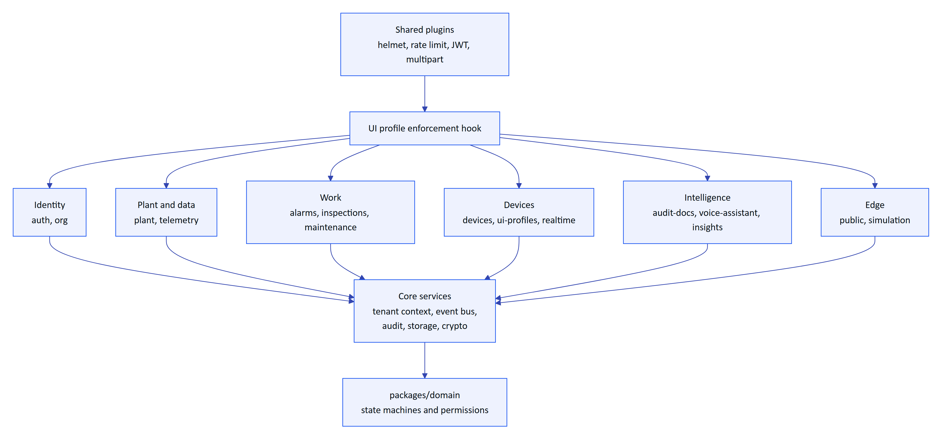
Figure 2. Module map. Route modules sit on shared plugins and core services; the domain package supplies rules.
Table 1. API modules and what each owns (route counts from apps/api/src/modules/*.ts)
Module | Routes | Owns | Rule worth knowing
auth | 17 | Sign-in, MFA, refresh, invitations, resets, sessions, org switch | Lockout after 5 failures for 15 min
org | 13 | Organization, members, notifications, audit log, platform orgs | No role escalation
plant | 28 | Sites, facilities, areas, assets, sensors, gateways, documents, attachments | Attachments only through the authorised route
telemetry | 6 | Ingestion, manual and lab entry, history, CSV, corrections | One ingest() path, idempotent per sensor and time
alarms | 9 | Rules, events, transitions, stale-data evaluation | Deadband, on-delay, note required to resolve
inspections | 15 | Templates, routes, inspections, responses, review | Offline replay by client operation id
maintenance | 7 | Work orders, checklists, activity | Transitions from the domain package
devices | 16 | Pairing, device tokens, device context, fleet admin | Session version and refresh family revocation
ui-profiles | 13 | Glasses UI profiles, versions, assignments | Enforced on device requests
realtime | 1 | Event stream (SSE) | Per-connection, per-event authorisation
audit-docs | 12 | Scanned records: capture, enhance, review, verify, approve, PDF | Four-eyes approval, optimistic concurrency
voice-assistant | 1 | Grounded spoken answers | Read-only tools, 60 per min
insights | 4 | Overview KPIs, document assist, search, reports | Read-only
public | 1 | Website contact and demo requests | 5 per 10 min
simulation | 3 | Demo scenarios | Synthetic data refused for customer tenants

1.3 The request lifecycle
Every authenticated call follows the same path, and the order is deliberate. The principal is resolved from the database on every request, so a revoked session or device stops working at once, not when its token expires. Device principals then pass the UI profile check. Only then does the handler run, inside a tenant transaction where Postgres itself filters rows.
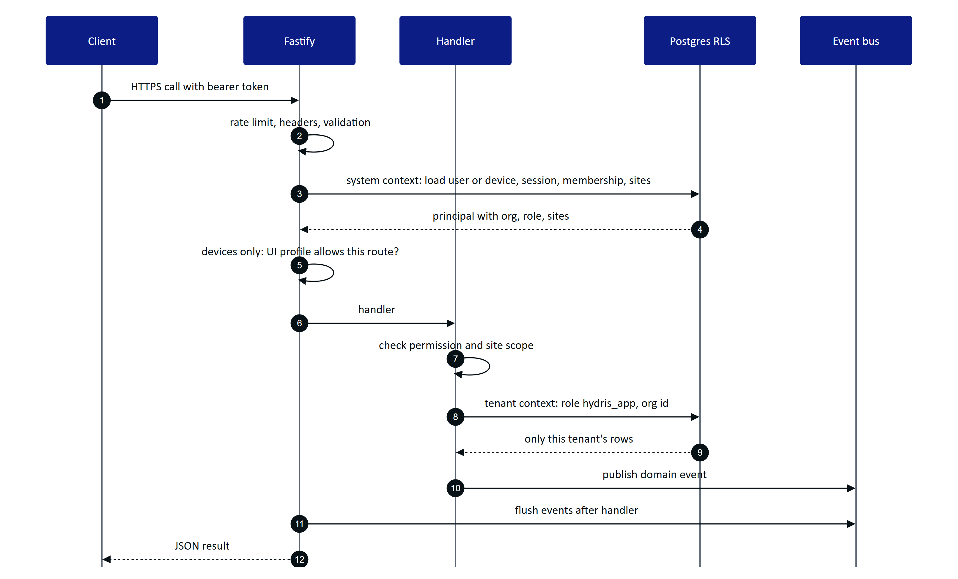
Figure 3. Request lifecycle. Authentication reloads the principal; the handler runs in a tenant transaction; events flush after the response is built.
Three outcomes are worth naming. Out-of-scope records return 404, not 403, so a user cannot probe for another site's assets. Every error uses one JSON shape with a stable code (validation_failed, note_required, stale), which the clients turn into plain messages. Unexpected errors return a masked 500 and the stack stays in logs.

1.4 Identity, sessions and device tokens
People sign in with email and password (argon2id hashing, optional TOTP MFA). They receive a 15-minute access token and a 7-day refresh token in an httpOnly cookie. Every refresh rotates the token within a family; a rotated token presented again after a 30-second multi-tab grace is treated as theft and the whole family is revoked. Because each access token carries its family id and the API checks the family on every request, logout and theft detection take effect immediately.
Devices never see a password. Glasses and phones pair through a flow shaped like the OAuth device authorisation grant (RFC 8628): the device shows a short code, a signed-in person approves it with a site and an operator, and the device receives its own tokens. A device then acts on behalf of its assigned operator, capped by a fixed ceiling of 13 device permissions.
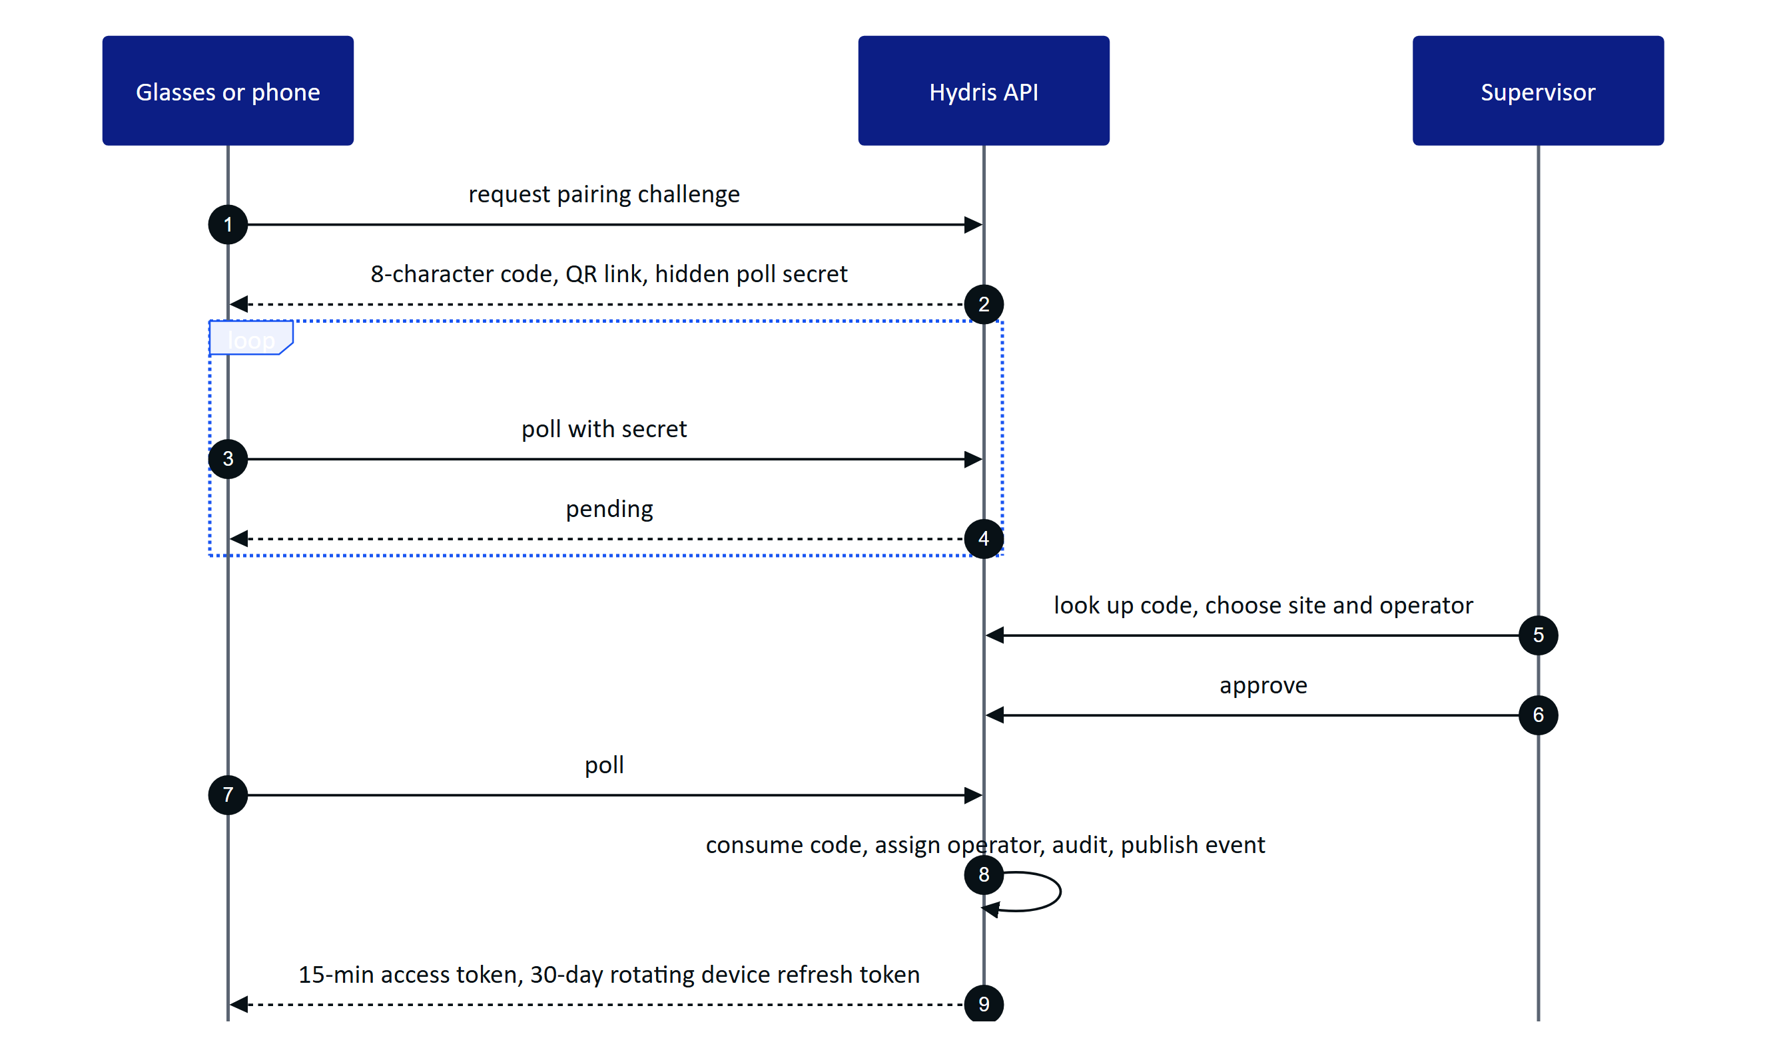
Figure 4. Device pairing. The code is single use, expires after 300 s, and no credential is ever shown on screen or in a QR code.
Table 2. Credentials at a glance
Credential | Lifetime | Revoked by
User access token | 15 min (12 h in demo mode only) | Family revocation, checked per request
User refresh token | 7 days, rotating | Logout, password change, reuse detection, session list
Device access token | 15 min | Session version bump on suspend, revoke, reassign
Device refresh token (hgd_) | 30 days, rotating | Revoke, logout, reuse detection
Gateway key (hgw_) | Until revoked | Admin revoke; stored only as a hash

1.5 Realtime events
Alarms, telemetry, work updates and device changes reach clients over Server-Sent Events. The stream is opened with fetch, so the bearer token travels in a header and never in a URL. Events carry identifiers and small payloads; clients refetch through the normal API, so authorisation is never bypassed. Every event is checked per connection (organization, target user or device, site, permission) before it is sent.
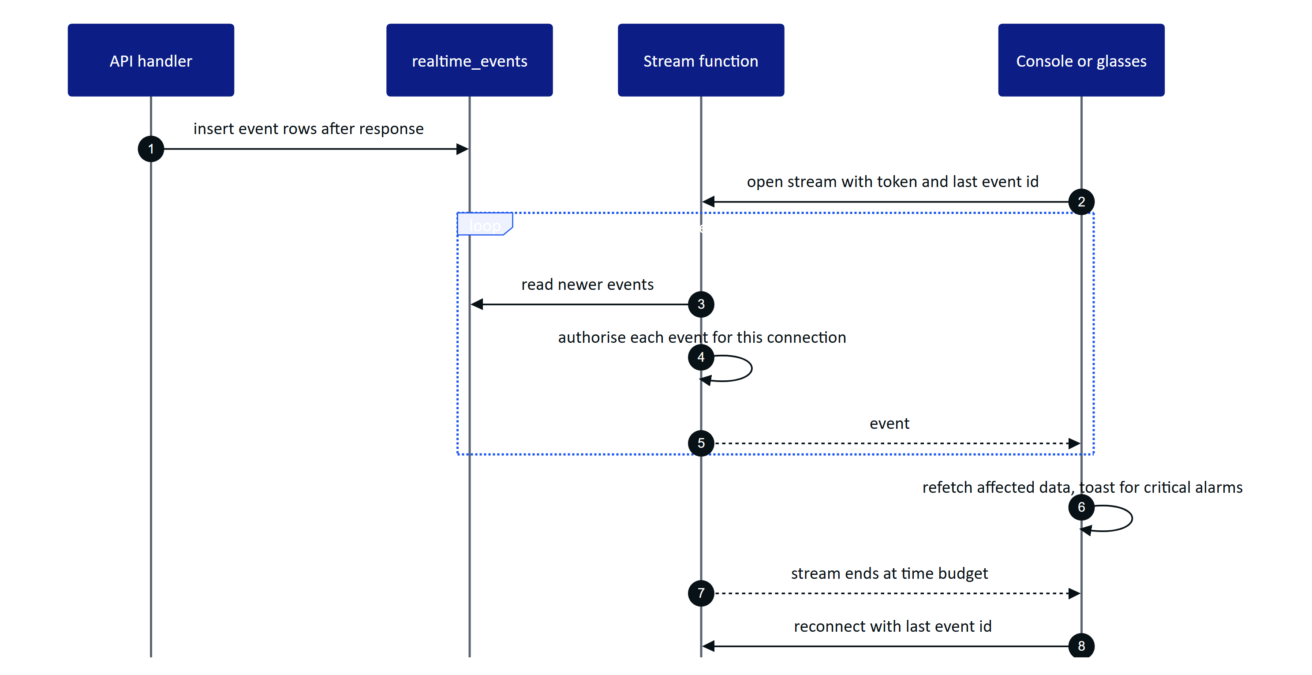
Figure 5. Realtime in db mode. A handler writes event rows; each open stream polls, filters per connection and resumes after reconnect without gaps.
Table 3. Realtime modes (REALTIME_MODE in apps/api/src/core/events.ts)
Aspect | memory | db
Fan-out across instances | No, single instance | Yes, all instances read one table
Replay on reconnect | Last 1,000 events | Any event still stored (pruned after 1 day)
Latency | Immediate | Up to 1.5 s poll
Used by | Docker Compose, long-running server | Vercel, demo, multi-instance

The console batches cache invalidations every 1.5 s but raises a toast at once for critical and high alarms; the Android app raises a system notification.

1.6 The data model by domain
The schema has 42 tables in ten domains, each owned by one module. Plant objects are archived, not deleted; telemetry and the realtime log use big integer keys; everything else uses UUIDs. Four views carry the essentials.
8  identity and tenancy tables  users are global, membership is per org |  | 8  plant and telemetry tables  site to sensor hierarchy, immutable readings |  | 11  alarm and work tables  rules, events, inspections, maintenance |  | 10  device, UI and audit document tables  pairing, profiles, scanned records

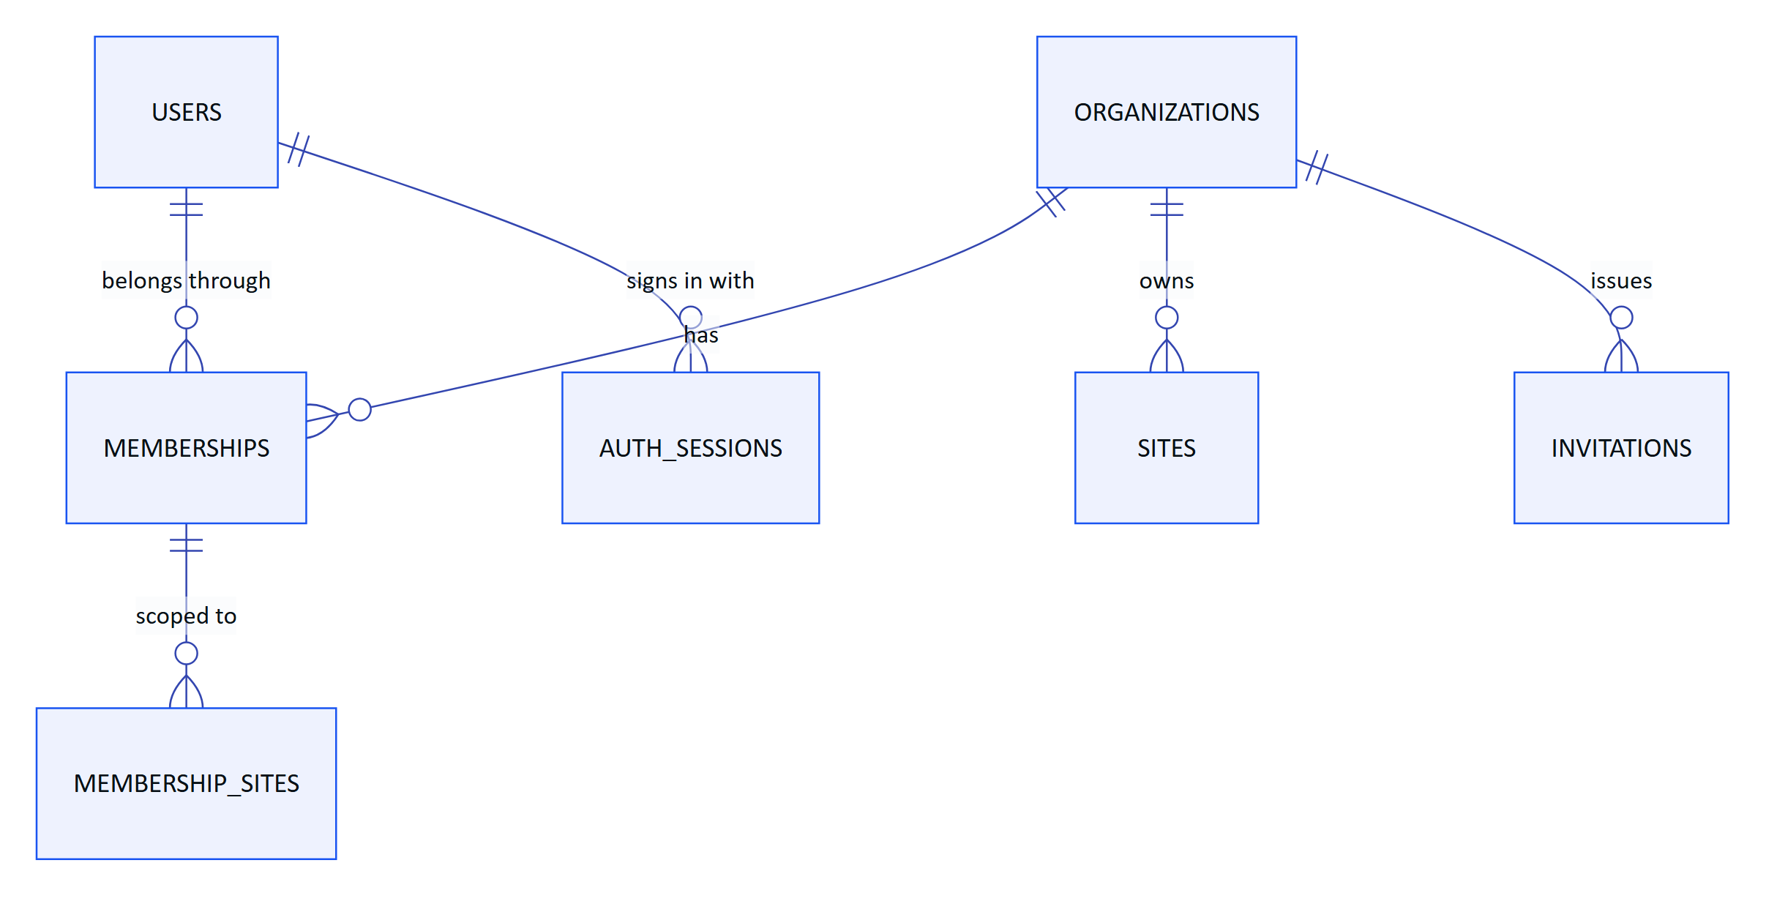
Figure 6. Identity and tenancy. A global user joins organizations through memberships, optionally scoped to sites.
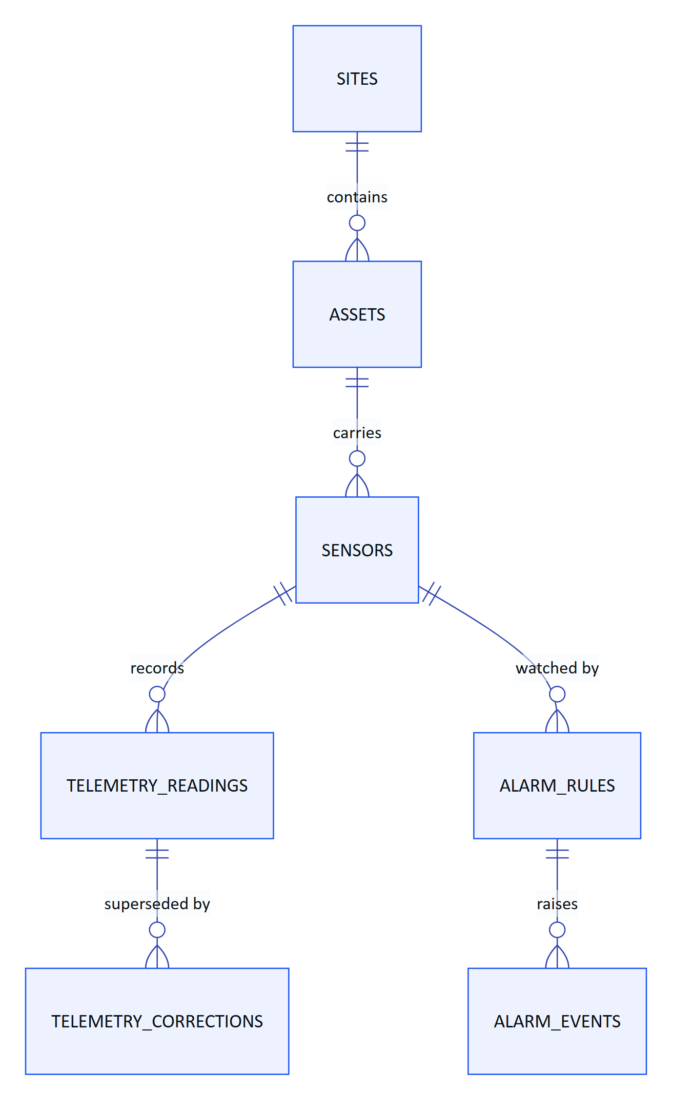
Figure 7. Plant, telemetry and alarms. Readings are immutable; corrections and alarm events reference them.
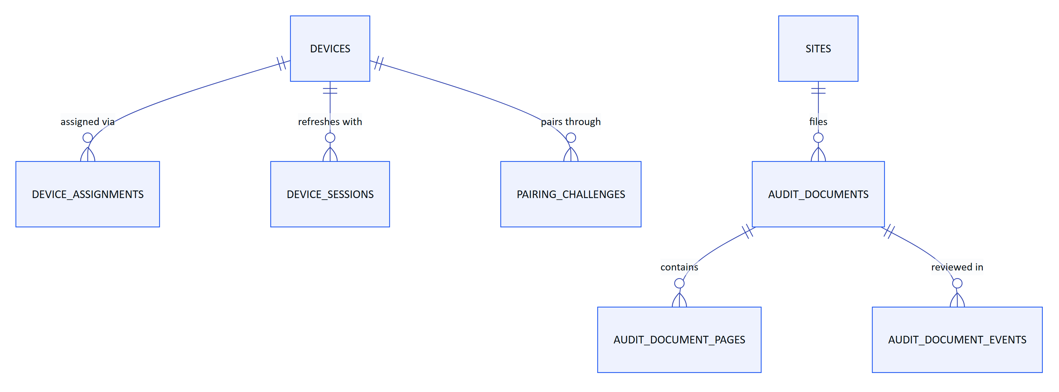
Figure 8. Devices and scanned audit documents. A device is assigned to one operator; a document holds pages and an append-only event trail.
Work (inspection templates, routes, inspections, responses, maintenance tasks and activity) hangs off sites and assets in the same way, and inspection records carry a revision counter for safe offline replay. Records are evidence: manual and lab readings keep provenance, corrections never overwrite the original reading, and synthetic data is marked and refused for customer tenants by a database check.

1.7 Tenancy and data isolation
Isolation is enforced by Postgres, not only by application code. Every tenant table has row-level security enabled and forced, with one policy that compares the row's organization with a per-transaction setting. Requests run as a non-privileged role, hydris_app, that cannot bypass the policy.
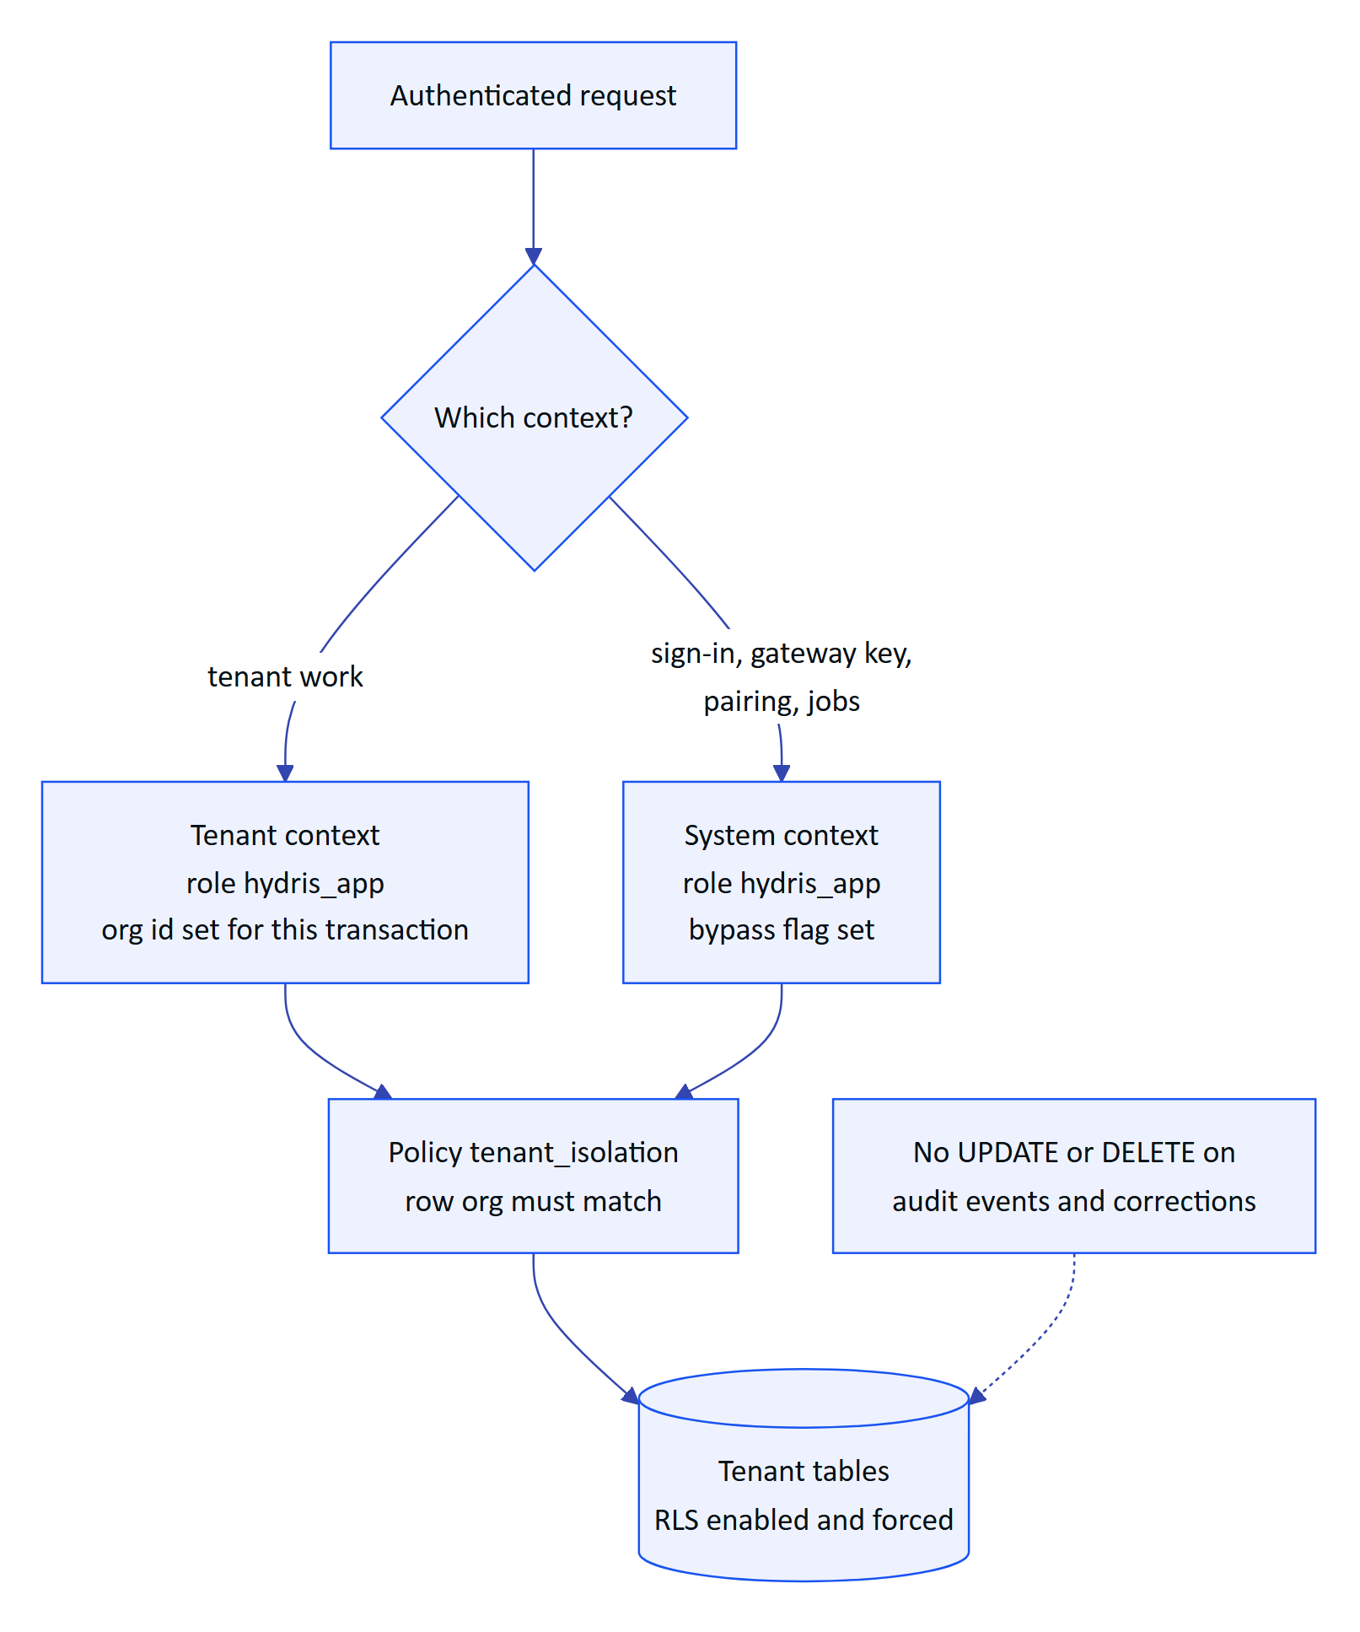
Figure 9. Tenant isolation. Both contexts run as the non-privileged role; only the session settings differ.
Settings use SET LOCAL, so nothing leaks to the next request on a pooled connection. Append-only grants hold even in system context. The application adds RBAC (six roles, 38 permissions in packages/domain/src/roles.ts) and site scope on top, so a forgotten filter in a handler is a non-event rather than a breach.
WARNING
Owner and superuser connections bypass RLS. Production must connect as a runtime user that is a member of hydris_app and not the table owner. Today the same owner user runs migrations and the application.

1.8 Telemetry ingestion and integrations
Hydris never connects into a plant. A gateway on the customer side pushes readings outward over HTTPS with a hashed hgw_ key, up to 500 readings per call. Ingestion is idempotent per sensor and timestamp, so a gateway can retry safely after an outage, and it returns per-reading rejections so the gateway can retry or drop single readings. Manual and lab entries and the demo simulator use the same ingest() path.
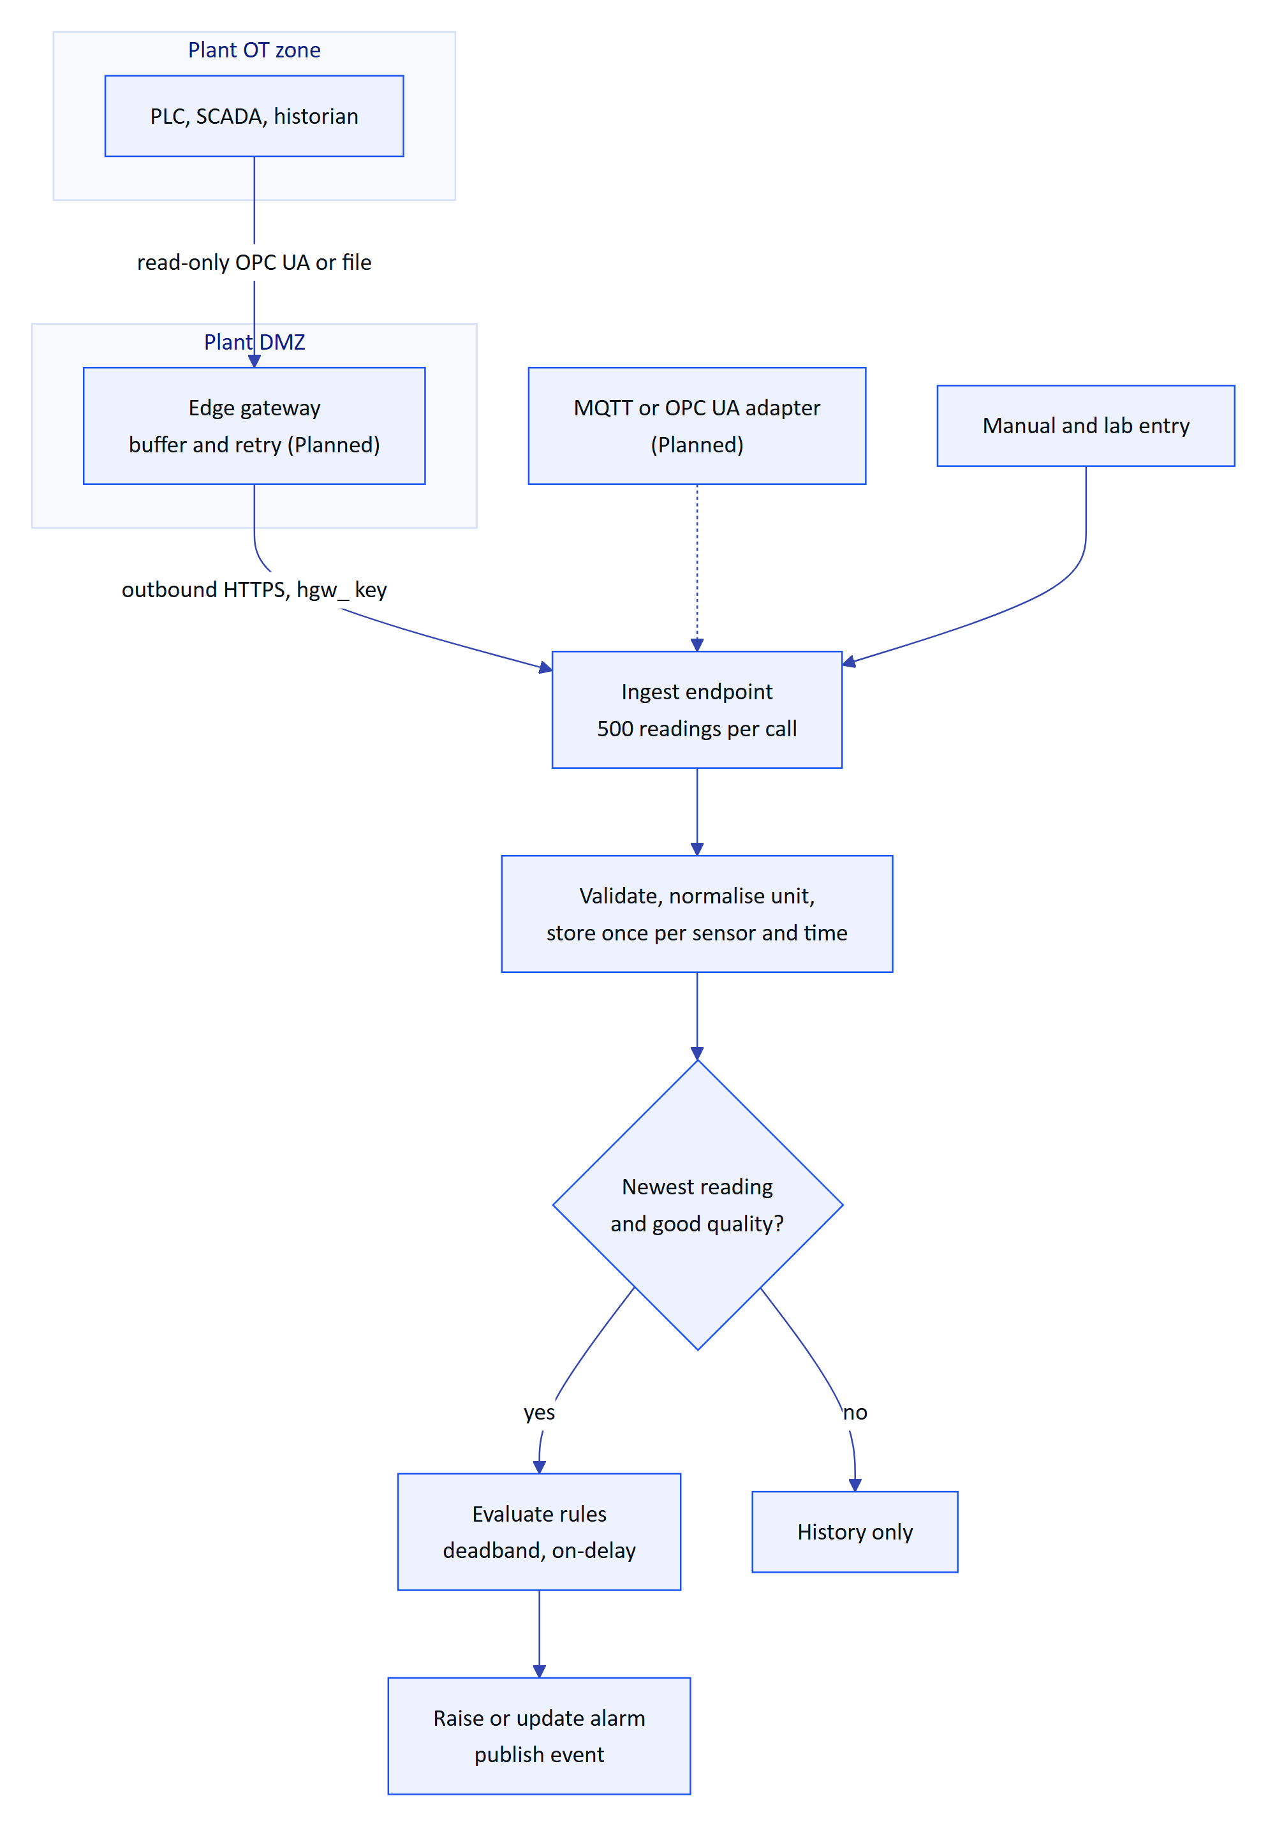
Figure 10. Telemetry flow from the plant to an alarm. The edge gateway and MQTT or OPC UA adapters are planned; the HTTPS contract is built.
Design details keep alarms honest: late data is stored for history but does not overwrite a newer value or re-trigger rules; once in alarm, a value inside the deadband reports "holding" so a noisy signal does not flap; a breach must persist for the on-delay before an alarm is raised; and there is one open event per rule. Stale-data rules cannot run on ingestion, because the problem is the absence of readings, so they run as a background job.
Table 4. Integration status
ID | Integration | Status
FR-022 | HTTPS gateway ingestion, 500 readings per call, idempotent | Built
FR-023 | Manual and lab entry with provenance | Built
FR-024 | Append-only corrections | Built
FR-027 | MQTT and OPC UA ingestion adapters | Planned (Advanced)
FR-028 | Read-only SCADA and historian connectors | Planned (Advanced)
FR-029 | Synthetic data labelled and refused for customer tenants | Built
n/a | Edge gateway software (store and forward) | Planned; API contract Built

1.9 AI services and the human in the loop
Two features use a model (Claude, through @anthropic-ai/sdk), and both are optional. Without a credential, audit scans keep their on-device OCR results and the assistant uses a deterministic rules engine. The model never sees the database: the assistant can only call five read-only tools (get_readings, get_open_alarms, get_my_work, get_asset, search_procedures), and they run inside the caller's tenant transaction, so RLS and site scope apply to every lookup.
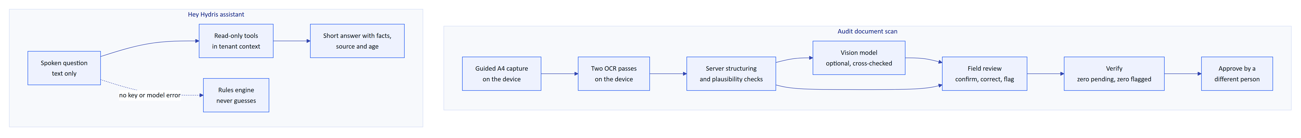
Figure 11. AI flows. Vision adds a second opinion to on-device OCR; the assistant answers only from tenant-scoped tools; people decide what becomes a record.
Table 5. AI requirements
ID | Requirement | Status
FR-063 | Optional vision engine cross-checked against OCR text | Built (needs API key)
FR-064 | Field review; verify requires zero pending and zero flagged items | Built
FR-065 | Independent four-eyes approval | Built
FR-072 | Assistant answers only from tenant data; rules fallback never guesses | Built
FR-078 | Assistant has no write tools | Built
NFR-035 | Only values returned by tools in the same conversation | Built (prompt and tool design)
NFR-037 | Graceful degradation without the model | Built
NFR-039 | Human in the loop for every AI-extracted value | Built
NFR-040 | Model provider and region documented per tenant | Planned (GA)

Vision cannot replace an extraction once review has started, and every review write carries a revision so a lost race returns a conflict instead of overwriting a colleague's work.

1.10 Background jobs
Four jobs keep the platform current. On a long-running server they run on timers; on Vercel they run from a cron route protected by a secret; in demo mode a lazy ticker advances them on API activity.
Table 6. Background jobs by topology
Job | Long-running server | Vercel today | Demo
Stale-data alarm rules | Every 30 s | Daily (0 3 * * *) | Not ticked
Pairing challenge expiry | Every 60 s | Daily | Expiry checked on use
Realtime event pruning (older than 1 day) | Hourly | Daily | Per instance
Simulation steps | Every 5 s per run | Daily | On activity, at most every 5 s

WARNING
In the all-Vercel topology stale-data alarms are raised at most daily (FR-035 Partial, TD-02). A production plant needs a per-minute scheduler or the API in a container.

1.11 Key architecture decisions
Table 7. Architecture decision records (all Accepted, ARCHITECTURE.md)
ADR | Decision | Why | Trade-off
002 | Fastify modular monolith | One deployable, in-process calls | Modules must stay disciplined
003 | API inside the Next.js route with app.inject | One Vercel project, no network hop | Cold start builds the app and migrates
004 | Postgres RLS plus RBAC and site scope | Strong isolation in one schema | Every request is a transaction
005 | PGlite for development, tests and demo | Real Postgres semantics, no service | Per-instance memory in demo
007 | SSE over fetch for realtime | Works on serverless and proxies; token out of URLs | Polling in db mode
008 | Two event bus modes, memory and db | No extra infrastructure | 1.5 s latency in db mode
009 | On-device dual OCR, vision optional | Works offline and without AI | Vision only improves layout
011 | RFC 8628-style pairing | No credential on screen or in a QR | Code TTL, no attestation yet
012 | Push-only HTTPS ingestion from an edge gateway | Hydris stays outside control networks | Customer or partner runs the gateway
013 | Short JWTs plus rotating refresh tokens checked per request | Immediate revocation | One lookup per request
015 | LLM grounded through tenant-scoped tools with fallbacks | Answers cite real readings | Narrower coverage without the model
016 | Pure domain package shared by server and web | One definition of rules | Android mirrors by hand

1.12 Platform requirements and NFRs
Table 8. Platform requirements (IDs from PRD.md)
ID | Requirement | Status
FR-003 | Refresh rotation with family revocation on reuse | Built
FR-007 | Site-scoped permissions for every role except org admin | Built
FR-008 | Database-enforced tenant isolation | Built
FR-033 | Realtime push of alarm events to all clients | Built
FR-050 | Pairing with short code, QR, 5-min TTL, 3 s polling | Built
FR-051 | Device tokens with rotating refresh and reuse detection | Built
NFR-001 | API read latency p95 under 300 ms in-region | Partial (target, not measured)
NFR-002 | Realtime alarm delivery 2 s or less | Built (design, target not measured)
NFR-007 | Horizontal scale of realtime | Built (db mode)
NFR-008 | Scheduled jobs at a cadence suitable for real data | Partial (daily on Vercel)
NFR-009 | Backups and tested restore | Planned
NFR-011 | Tenant isolation enforced in the database | Built
NFR-012 | Short-lived credentials | Built
NFR-013 | Rate limiting | Built (per instance)
NFR-030 | Provenance on every reading | Built
NFR-031 | Optimistic concurrency on review records | Built
NFR-032 | Shared domain logic between server and clients | Built

1.13 The technical debt that matters
The register in ARCHITECTURE.md lists 18 items. These are the ones that decide whether a pilot runs well and whether the platform scales.
Table 9. Technical debt that matters
ID | Debt | Impact | Fix
TD-01 | Root .gitignore hides the Android data package | A fresh clone of the Android app does not compile | Anchor the rule, commit the package
TD-02 | Vercel cron runs daily | Stale-data alarms up to a day late | Per-minute scheduler or hybrid topology
TD-03 | In-memory rate-limit store | Limits are per instance | Shared store or edge firewall
TD-04 | Audit page images in Postgres as base64 | Database and backup growth | Object storage behind the storage adapter
TD-05 | Empty contracts package; Android models by hand | Contract drift | Generate schemas and Kotlin models
TD-06 | No CI pipeline | Regressions found late | GitHub Actions workflow
TD-07 | db realtime polls every 1.5 s per stream | Database load grows with connections | LISTEN/NOTIFY or managed pub/sub
TD-10 | No telemetry partitioning or retention | Index cost at volume | Monthly partitions, retention per contract
TD-11 | Ingestion evaluates rules reading by reading | Throughput ceiling | Batch inserts and rule loading
TD-12 | No content security policy | Weaker defence against injected scripts | Nonce-based CSP

NOTE
Planning estimates, not measurements: at 200 sensors per site reporting every minute, one site produces about 288,000 readings a day. The bottlenecks arrive in the order TD-11, TD-07, TD-10, TD-04, which is the order the scaling plan addresses them.

